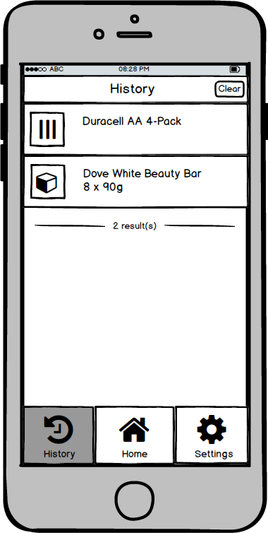

**OOOOO ABC O 828 PM**

**History III Durocell AA 4-Pack**

**Dove White Beauty Bar 8 x 40g**

**2 result(s)**

**o a**

**History HOme Settings**